LESSON GUIDE FOR READING BERRIES 4 – 5 YEARS CLASS

Middle 4 – 5 YEARS TERM ONE 2023

WEEK ONE

Orientation

-Touring different places in section

-Our classroom

-Washing places

-Toilets

-Other classrooms

**Lesson 3**

Revision of baby class work

s a t i p n

-Identifying sounds orally

-Matching the same sounds

**Lessons 4**

**Copy and write**

s a t i p n

**Lesson 5**

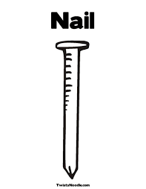Matching a picture to a sound

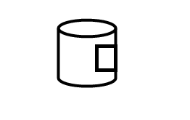s

a

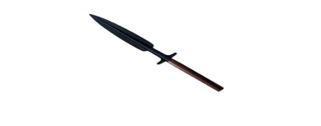t

i

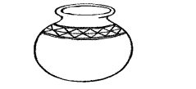p

n

**WEEK 2**

**Lesson 1**

Listen and write set 2

e m ck d r h

**Lesson 2**

Draw pictures for the given sounds

c r e d h m

**Lesson 3**

**Revising sound in the 3rd set**

g o u f b

**Forming words**

hen top gun red sit

pin get pot pen

**Lesson 4**

**Matching the same words**

sit tin

bed rat

pan pen

tin gun

rat sit

pen bed

gun pan

**Lesson 5**

Match sounds to their pictures.

m



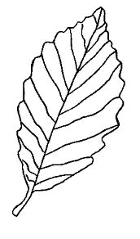h

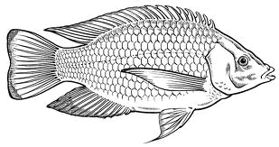e

i

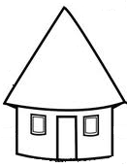b

f

**WEEK 3**

**Lesson 1**

**Vowel sounds**

Copy and write

a e i o u

___ ___ ___ ___ ___

___ ___ ___ ___ ___

**Lesson 2**

**Matching vowels to pictures**

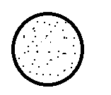a

e

i

o

u

**Lesson 3**

**Copy and write**

a - axe at an ant

e - egg end elf

i - in is is ill ink

o - on of oil

u - up under

**lesson 4**

**Match a vowel to a vowel**

**a** up

**i** egg

 on

**o** ink

**e** ant

**Lesson 5**

**Ring a word for a vowel**

**a** = pan red

**e** = tap egg

**i** = tin rat

**o** = of axe

= = leg up

**WEEK 4**

**Consonant sounds**

**Lesson 1**

**Copy and write**

**b c d f g h**

**____ ____ ____ ____ ____ ____**

**j k l m n p**

**____ ____ ____ ____ ____ ____**

**q r s t v w**

**____ ____ ____ ____ ____ ____**

**x y z**

**____ ____ ____**

**Lesson 2**

**Circle consonants only**

**a b e f g i**

**t o p s d**

**h e r i k o**

**Lesson 3**

**Listen and write**

h m f b g j p

s d t c h k n

**lesson 4**

**Write the beginning sound**

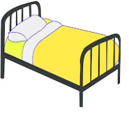

ed at

ut

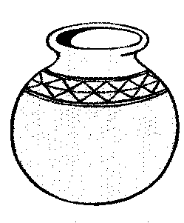

un ot

**Lesson 5**

**Draw a picture for the sounds**

r b c t f

p

**WEEK 5**

**Form syllables of a**

b – a = ba v – a = va

m - a = ma c – a = ca

w – a = wa d - a = da

g – a = ga f – a = fa

t – a = ta p – a = pa

**Lesson 2**

**Forming words for the syllables.**

ba – g = ha – t =

ca – t = ya – t =

ta – p = ma – t =

ra – t = va – n =

ma – n = ra – n =

**Lesson 3**

**Matching syllables to the words**

ha bag

fa rat

ma tap

ba cat

ta hat

ra fan

ca mat

**Lesson 4**

**Read and draw**

rat yam mat

bag cat fan

hat fan man

**Lesson 5**

**Write words correctly**

cta pna

gab yma

tah tfa

nam mda

**WEEK 6**

**Syllables of e**

**Lesson 1**

**Copy and write**

he je ke be se de te ve

___ ___ ___ ___ ___ ___ ___ ___

le ze me ge fe ne pe

___ ___ ___ ___ ___ ___ ___

**Lesson 2**

Draw a picture for the syllables

be _____ ne _____ pe _____ le _____

**Lesson 3**

**Forming words**

be – d = fe - d =

le - g = he – n =

ge – t = me – n =

ne-t = je- t =

**Lesson 4**

**Read and draw**

bed - egg -

net - ten -

leg - vest -

hen - nest -

**Lesson 5**

**Read and write**

- A hen has eggs

- Ben has a red pen.

- It is very wet.

- Let men get a net.

**WEEK 7**

**Lesson 1**

**Syllables of i**

**Underline syllables of vowel**  **i**

ca ti be

gi re le

hi ma si

fa di te

ni ge mi

je pi da

**Lesson 2**

**Listen and write**

si ti pi ni gi mi di

ki yi ri wi hi zi

**Lesson 3**

**Draw a picture for a syllable**

ti mi wi si

pi hi ki di

lesson 4

**Fill in vowel i and draw**

t - n f - sh

h – ll d – sh

p – n p – g

s – x z – p

**Lesson 5**

**Read and draw**

- It is a pin.

- Six big tins.

- The fish is here.

- I can dig a pit.

- The pig is on a hill.

**Week 8**

**Lesson 1**

**Syllables of “o”**

**Copy and write**

co bo go ho no so po

zo do jo fo ko mo fo

**Lesson 2**

**Forming words**

co- t = jo – y = ko – b =

bo – y = bo – x = co – b =

ho – t = do – g = no – t =

po – t = mo – p = to – y =

fo – x = lo – g = do – ll =

**Lesson 3**

**Draw a picture for the syllables**

bo - fo - po -

bo - do – lo –

**Lesson 4**

**Ring words of syllable “o”**

bag ten box

toy sun bed

axe hot tin

pot dam egg

cat doll fish

dog net pan

**Lesson 5**

**Read and write**

- This is a pot.

- Joy has a box.

- A dog and a fox.

- The boy can mop.

- It is very hot.

**WEEK 9**

**Lesson 1**

**Syllables of “u”**

**Circle the odd man out**

ta ta tu

bu ga fa

fu fi ti

co hu co

se de mu

gi gi ru

**Lesson 2**

**Fill in vowel “u” and draw**

s n g n

c p j p

b s dr m

**Lesson 3**

Fill in the correct vowel

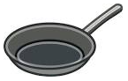

p n b x

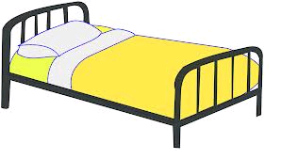

t n b d

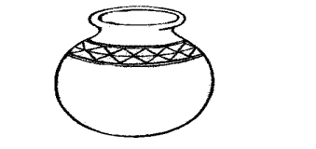

p t 6 s x

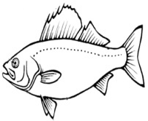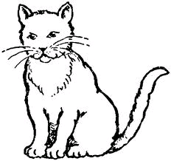

f sh c t

**Lesson 4**

**Write the word correctly**

guj - snu - sbu -

nug - tcu - nur -

tuh - pcu -

**Lesson 5**

**Copy and write**

- Mum has a gun.

- Run to the bus.

- The jug is in the hut.

- I can see the sun.

- They are ten cups.

- I can cut a tree and run.